**Department of Electrical Engineering and   
Computer Science**

**Faculty Member:** Dr. Mohsin Kamal **Dated:** 14/09/2023

**Semester:** 7th **Section:** BEE 12C

**CS-477 Computer Vision**

Lab 1: Python Programming – An Introduction

**Group Members**

|  |  |  |  |  |  |  |
| --- | --- | --- | --- | --- | --- | --- |
|  |  | **PLO4 - CLO4** | | **PLO5 -CLO5** | **PLO8 -CLO6** | **PLO9 -CLO7** |
| **Name** | **Reg. No** | **Viva / Quiz / Lab Performance** | **Analysis of Data in Lab Report** | **Modern Tool Usage** | **Ethics and Safety** | **Individual and Teamwork** |
|  |  | **5 Marks** | **5 Marks** | **5 Marks** | **5 Marks** | **5 Marks** |
| Muhammad Ahmed Mohsin | 333060 |  |  |  |  |  |
| Muhammad Umer | 345834 |  |  |  |  |  |
|  |  |  |  |  |  |  |
|  |  |  |  |  |  |  |

**Table of Contents**

2 Python Programming – An Introduction 3

2.1 Introduction 3

2.2 Objectives 3

2.3 Software 3

3 Lab Tasks 4

3.1 Task 1 4

3.2 Task 2 4

3.3 Task 3 5

3.4 Task 4 6

3.5 Task 5 7

4 Conclusion 8

# Python Programming – An Introduction

## Introduction

This laboratory exercise is meant to introduce the fundamental aspects of the python programming language which will be very important in the later labs of the course.

## Objectives

The following are the main objectives of this lab:

* Create variables of different data types in python
* Use arithmetic and logical operations in python
* Implement conditional statements and loops in python
* Create functions and call them in python
* Implement lists and dictionaries in python
* Read and write to files in python

## Software

Python is an open source, interpreted language which is widely used for machine learning tasks in research, academia, and industry. It has an easy-to-learn syntax and is ideal for writing programs in a short duration. The python interpreter can be downloaded from the website and installed on the system. By default, the IDLE program is installed. For machine learning, it is recommended to switch to a more powerful IDE such as PyCharm, Spyder, and Jupyter, etc.

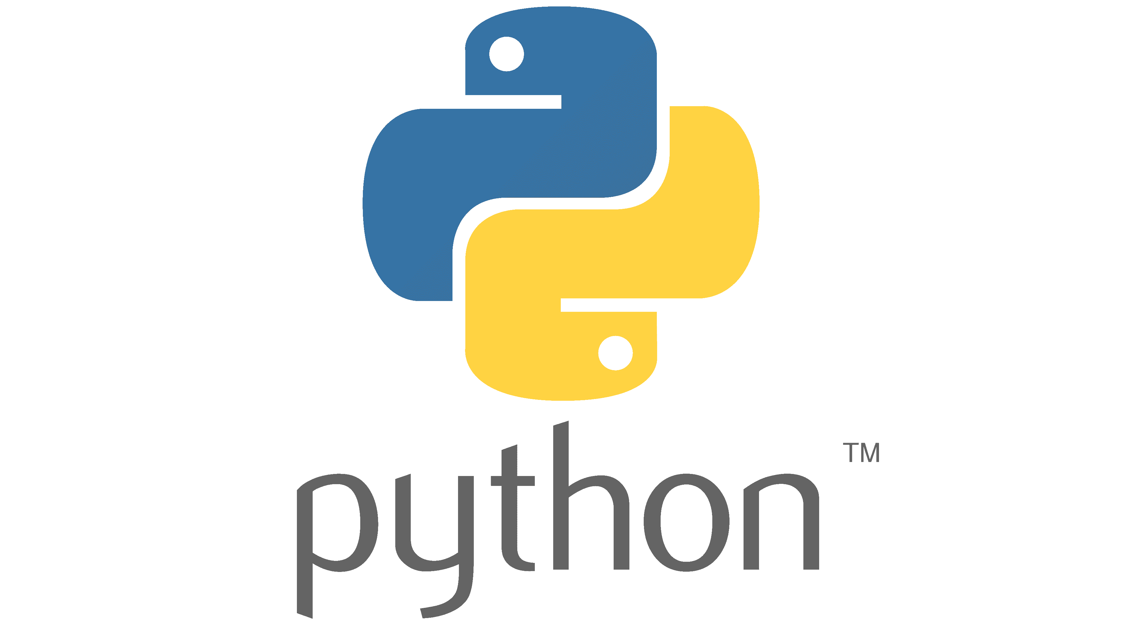

# Lab Tasks

## Task 1

Write a program that prompts the user for two numbers as input. Then, the program must compare the two numbers and print if they are equal or not. If the numbers are not equal, it must also print which number is greater (or lesser) than the other. The syntax for conditional statements as follows:

**if** condition:

statement_1

**else**:

statement_2

### Task 1 Code Starts Here ###

*# Input two numbers*

a = *int*(input("Enter first number: "))

b = *int*(input("Enter second number: "))

if a == b:

    print("Both numbers are equal")

else:

    print("The numbers are not equal")

    if a > b:

        print("{} is greater than {}".format(a, b))

    else:

        print("{} is lesser than {}".format(a, b))

### Task 1 Code Ends Here ###

### Task 1 Screenshot Starts Here ###

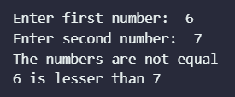

### Task 1 Screenshot Ends Here ###

## Task 2

Create a list with the sequence 1, 2, 3… 20. Then using the slice operation (:) on this list, print the following sub-lists:

5, 6, 7… 20

1, 2, 3… 12

7, 8, 9 … 16

4, 5

11, 12, 13, 14

### Task 2 Code Starts Here ###

main_list = *list*(range(1, 20+1))

print("Sub-list 1: ", main_list[4:])

print("Sub-list 2: ", main_list[0:12])

print("Sub-list 3: ", main_list[6:16])

print("Sub-list 4: ", main_list[3:5])

print("Sub-list 5: ", main_list[10:14])

### Task 2 Code Ends Here ###

### Task 2 Screenshot Starts Here ###

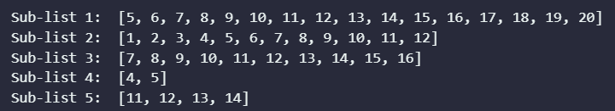

### Task 2 Screenshot Ends Here ###

## Task 3

Write a function that takes 2 lists as arguments. Both the lists must be of the same length. The function should calculate the product of the corresponding items and place them in a third list. You must NOT use the product operator (*). You need to provide the function definition and the function call in the code. The function definition syntax is given as follows:

**def** function_name:

statement_1

…

**return** output

### Task 3 Code Starts Here ###

*def* list_product(*list_1*, *list_2*):

    list_3 = []

    for i in range(len(list_1)):

        sum = 0

        for j in range(list_1[i]):

            sum += list_2[i]

        list_3.append(sum)

    return list_3

list_1 = [1, 2, 3, 4, 5]

list_2 = [10, 20, 30, 40, 50]

print("List 1: ", list_1)

print("List 2: ", list_2)

print("List 3: ", list_product(list_1, list_2))

### Task 3 Code Ends Here ###

### Task 3 Screenshot Starts Here ###

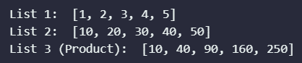

### Task 3 Screenshot Ends Here ###

## Task 4

In this task, you will make use of dictionaries. Write a program that first prompts the user to input five strings which will be the keys of the dictionary. Then, the program must prompt the user to input the values of the respective keys. When entering the values, the user must be shown the key whose value is being input. Once all values are entered, display the dictionary.

### Task 4 Code Starts Here ###

*# create an empty dictionary*

task_dict = {}

*# prompt the user to input five keys*

for i in range(5):

    key = input("Enter key " + *str*(i + 1) + ": ")

    task_dict[key] = None

*# prompt the user to input values for each key*

for key in task_dict:

    value = input("Enter value for " + key + ": ")

    task_dict[key] = value

*# display the dictionary*

print(task_dict)

### Task 4 Code Ends Here ###

### Task 4 Screenshot Starts Here ###

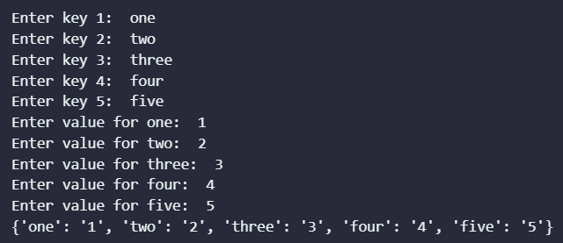

### Task 4 Screenshot Ends Here ###

## Task 5

In this task, you will focus on file handling. Write code that first creates a text file “lab2.txt” with the message “My name is <your_name>”. Then, your code must open the file in *read* mode and display the contents of the text file. Next, the file must be opened in *append* mode and the message “My registration number is <reg_number>” must be added to the text file. Finally, the file is read again to display the modified contents.

### Task 5 Code Starts Here ###

*# create a text file with the message "My name is Muhammad Umer"*

with open("lab2.txt", "w") as f:

    f.write("My name is Muhammad Umer")

*# open the file in read mode and display the contents*

with open("lab2.txt", "r") as f:

    contents = f.read()

    print("File Contents:\n" + contents)

*# open the file in append mode and add the message "My registration number is 345834"*

with open("lab2.txt", "a") as f:

    f.write("\nMy registration number is 345834")

*# read the file again and display the modified contents*

with open("labt2.txt", "r") as f:

    contents = f.read()

    print("\nModified Contents:\n" + contents)

### Task 5 Code Ends Here ###

### Task 5 Screenshot Starts Here ###

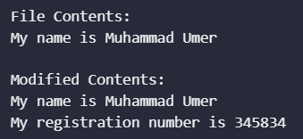

### Task 5 Screenshot Ends Here ###

# Conclusion

In conclusion, this lab successfully addressed the main objectives, which encompassed a wide range of fundamental Python programming concepts. We learned how to create variables of various data types, apply arithmetic and logical operations, implement conditional statements and loops for control flow, create and utilize functions, manipulate lists and dictionaries efficiently, and perform file operations for data input and output. These skills are essential for anyone looking to build a strong foundation in Python programming and will serve as valuable tools for future projects and tasks.